**IDEATION REPORT**

715519106018 – JOTHI KRISHNA T

715519106020 – KARTHIKEYAN A

715519106031 – NITHIYANANTH S

715519106059 – VIPIN L

**Gas Leakage Monitoring and Alerting System** **For Industries**

**Abstract:**

The Internet of Things aims to simplify life by automating all of the little tasks that we encounter. As much as IoT aids in task automation, its advantages can also be extended to improve current safety requirements. IoT has not been immune to the fundamental worry of any project, safety. Gas leaks can be fatal and harmful, whether they occur in open or closed spaces. Despite their high level of precision, conventional gas leak detection systems overlook a few important aspects in warning the public of a leak. In order to create a Gas Leakage Detector for society that has Smart Alerting Techniques that involve text messaging the appropriate authority, we used the Internet of Things (IoT) technology.

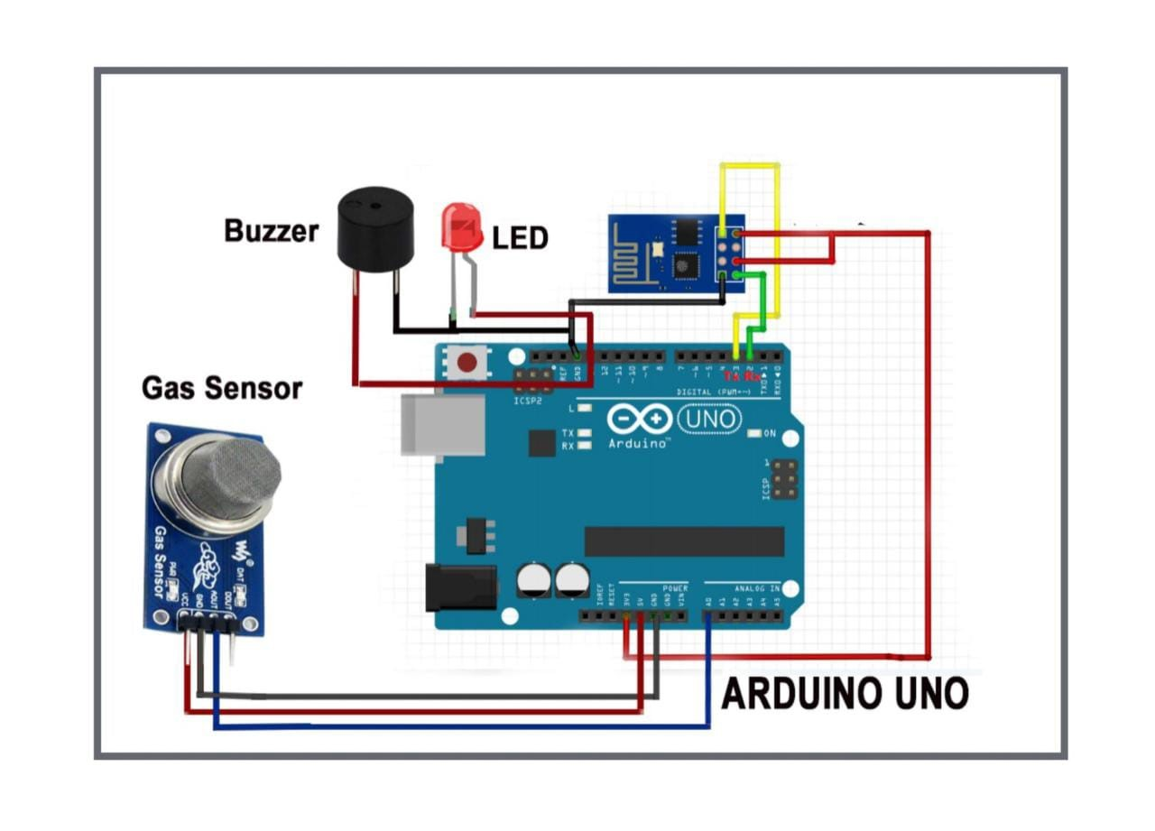

The Internet of Things aims to simplify life by automating all of the little tasks that we encounter. As much as IoT aids in task automation, its advantages can also be extended to improve current safety requirements. Safety has always been a top consideration when planning a home, a building, an industry, or a city.

It can be exceedingly dangerous for some gases to be present in the environment at higher concentrations. These gases may be hazardous after surpassing the stated concentration limits, combustible under specific temperature and humidity circumstances, or even contribute to local air pollution issues like smog and poor visibility, which can lead to serious accidents and have a negative impact on people's health.

The majority of civilizations have fire safety measures. But it can be used even after a fire has started. We developed a system using sensors that can detect gases like LPG, CO2, CO, and CH4 in order to have control over such situations. This device will be able to identify gas leaks and inform users via loud alarms as well.

This device can alert the user if there are excessive amounts of dangerous gases present in the surroundings. System can send a message to society administrators informing them of the situation before an accident occurs.

Gas detector sensors, an Arduino board, an ESP8266, and a cloud server make up the system. All flat member users can be registered on our system by a single society authority person. The administrator of the society can enter information on each flat's users, including their user name, phone number, and flat sensor information. Each sensor's threshold value can be set by society admin. Each flat can be equipped with system hardware.

The value per time can be sensed using sensors. Values can be sent from the system to a cloud server. The sensor values' existence at the threshold value can be checked by the server. The server can instruct the hardware to buzz the alert if the sensor value can exceed the limit. Additionally, the server notifies the user.

In this study, we employ IOT technologies to raise the bar for current safety regulations. The goal of creating this prototype was to revolutionize environmental safety by eliminating any major or minor hazards brought on by the release of hazardous and dangerous gases into the environment. We created a Gas Leakage Detector for society using IOT technology, and it has the ability to perform data analytics on sensors and Smart Alerting techniques that send text messages to the relevant authorities. Using gas sensors, this system will be able to identify any gases present in the surrounding area. This will shield us from the main detrimental issue.